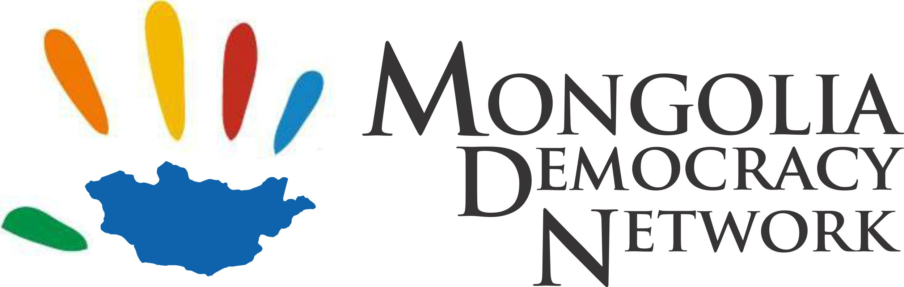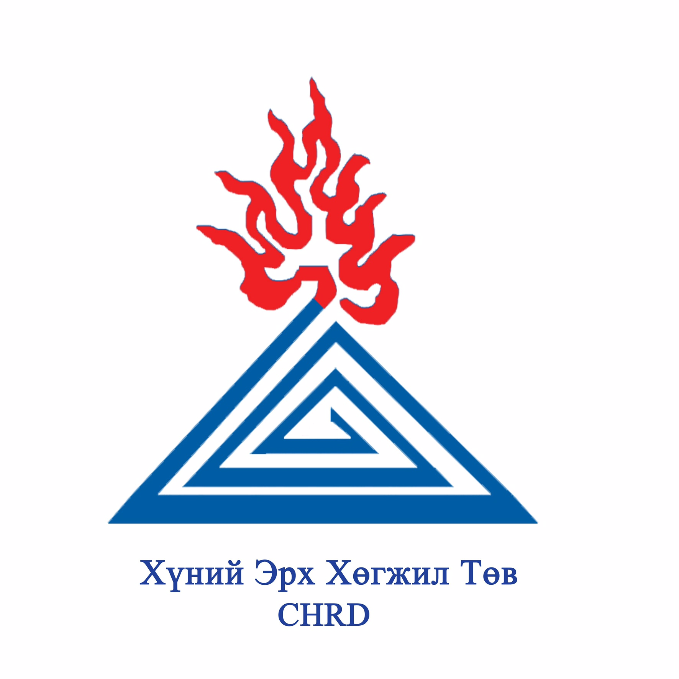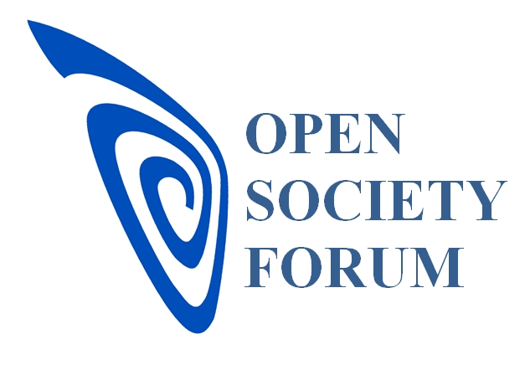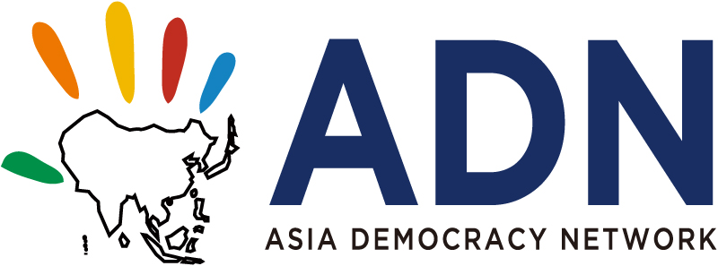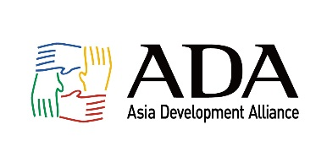

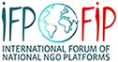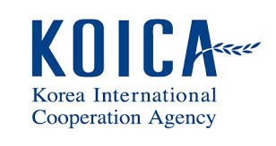

**Workshop on UN Sustainable Development Goals (SDGs) and**

**Role of Civil Society**

Ulaanbaatar, Mongolia / 10:30 am to 6 pm on 18 Aug. (Friday), 2017

* **Organizers:** Asia Development Alliance (ADA) and Asia Democracy Network (ADN) in partnership with Korea International Cooperation Agency (KOICA) and International Forum of National NGO/CSO Platforms (IFP)
* **Local Hosts** : Mongolia Democracy Network (MDN), Open Society Forum (OSF) and the Center for Human Rights and Development (CHRD) in Mongolia
* **When** : 10:30 am to 6 pm on Friday 18 Aug. 2017
* **Where** : OSF Conference Room in Ulaanbaatar <http://www.forum.mn/>
* **Lecturer and Facilitator** : Anselmo Lee, Co-convener of ADA and Secretary General of AND. [alee7080@gmail.com](mailto:alee7080@gmail.com) Mobile +82-10-4293-0707

Please contact the following local contact persons for enquiry and application (Deadline is 15 Aug. Tuesday 2017)

* Tur-od Lkhagvajav, MDN, [lturod@gmail.com](mailto:lturod@gmail.com) Mobile [+976-9919-1007](tel:+976%209919%201007)
* Manda Urantulkhuur, CHRD, [mandatsen@gmail.com](mailto:mandatsen@gmail.com) Mobile +976-9919-4455

**Program Agenda (tentative)**

|  |  |
| --- | --- |
| **Time** | **Contents** |
| **10:30 – 10:45** | **Welcome and introduction** |
| **11:45 – 12:30** | **Lecture 1 on Sustainable Development Goals (SDGs) – history, background, structure and contents** |
| **12:30 - 13:30** | **Lunch break** |
| **13:30 - 15:00** | **Lecture 2 on Sustainable Development Goals (SDGs) – implementation and monitoring with focus on SDG 16** |
| **15:00 - 16:00** | **Presentation on the state of SDG implementation in Mongolia by representative of Mongolian government** |
| **16:00 - 16:10** | **Break** |
| **16:10 – 17:00** | **Group discussion on 5 Ps (People, Prosperity, Planet, Peace and Partnership) and mapping about CSOs on SDGs** |
| **17:00 - 18:00** | **Lecture 3 on how to prepare for UN HLPF on Voluntary National Review (VNR) / Conclusion and closing remarks** |